Use Cases

Underserved Use Cases

**High fidelity:** Users can form a family circle to share and monitor everyone's location...

**Assumption**: Users set a family circle ahead of time. This assumption is necessary because many types of natural disasters occur too quickly for users to download and set up an application. Presumably, users in areas prone to dangerous events (earthquakes, tsunamis) have the application installed.

Specific use case: Janet wants to check and see where her family members are, and see if they are okay.

1. Janet starts on the map, where she can already see pins for family members whose locations are available to her. She pans around, and taps each family member one-by-one when she finds them.
2. When she tap’s “Dad’s Phone”, a popup with information about her dad comes up. She sees a green checkmark and the text “self-reported safe”, and feels a bit relieved.
3. Tapping out of this popup (by pressing anywhere outside of it), she continues searching. She finds “Bro’s Phone”, and taps on it. This time, there’s no green checkmark, but there is a last known location.
4. She can’t find any more family members, but sees the “unknown” list in the top right. She sees that her mom and grandma’s locations are not known.
5. Seeing the “more” button, she presses on it (anywhere on the list would work), and brings up another popup with a complete list of family members with unknown locations. She reads it, but chooses not to rearrange it.

See next page for drawings.

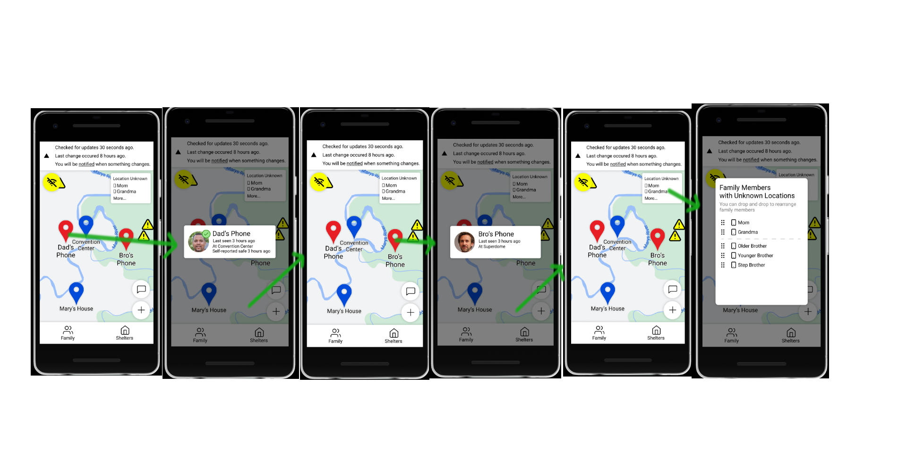

**High fidelity:** ...and choose a safe place as a meeting point. Locating temporary shelter, internet access, food (if your home was just destroyed or damaged, you need somewhere to be). This may include other important essentials (medications, insulin, contacts, female hygiene products).

Specific use case: The area in which Jane is currently in is unsafe and unsanitary. She wants to go somewhere near her family members. Because first responders (with phones) keep traveling back and forth to where she is, her phone has some data about nearby shelters.

1. She starts on the main screen, where she can drag to look for shelters.
2. She visually selects the pin closest to “Dad’s Phone”, but it is rated low from 2 reviews. She taps outside the popup to exit.
3. She visually selects another pin, “Mary’s House”. This pin has a high rating, and isn’t too far from other phones. She thinks that it’s where she wants to go.
4. Just in case, Janet taps on the “shelters” button to look through all available shelters. There aren’t too many, and she is further convinced to go to Mary’s house.

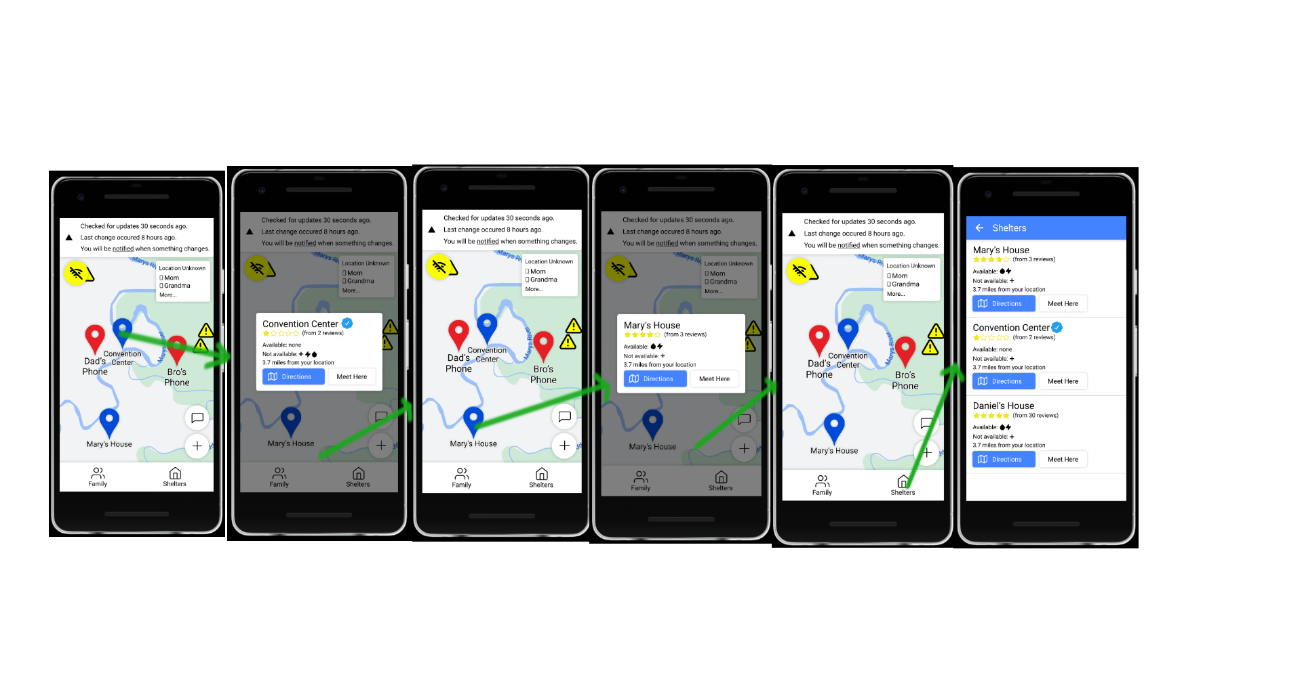

1. Janet also marks “Mary’s House” as the meeting point (this requires a confirmation dialog).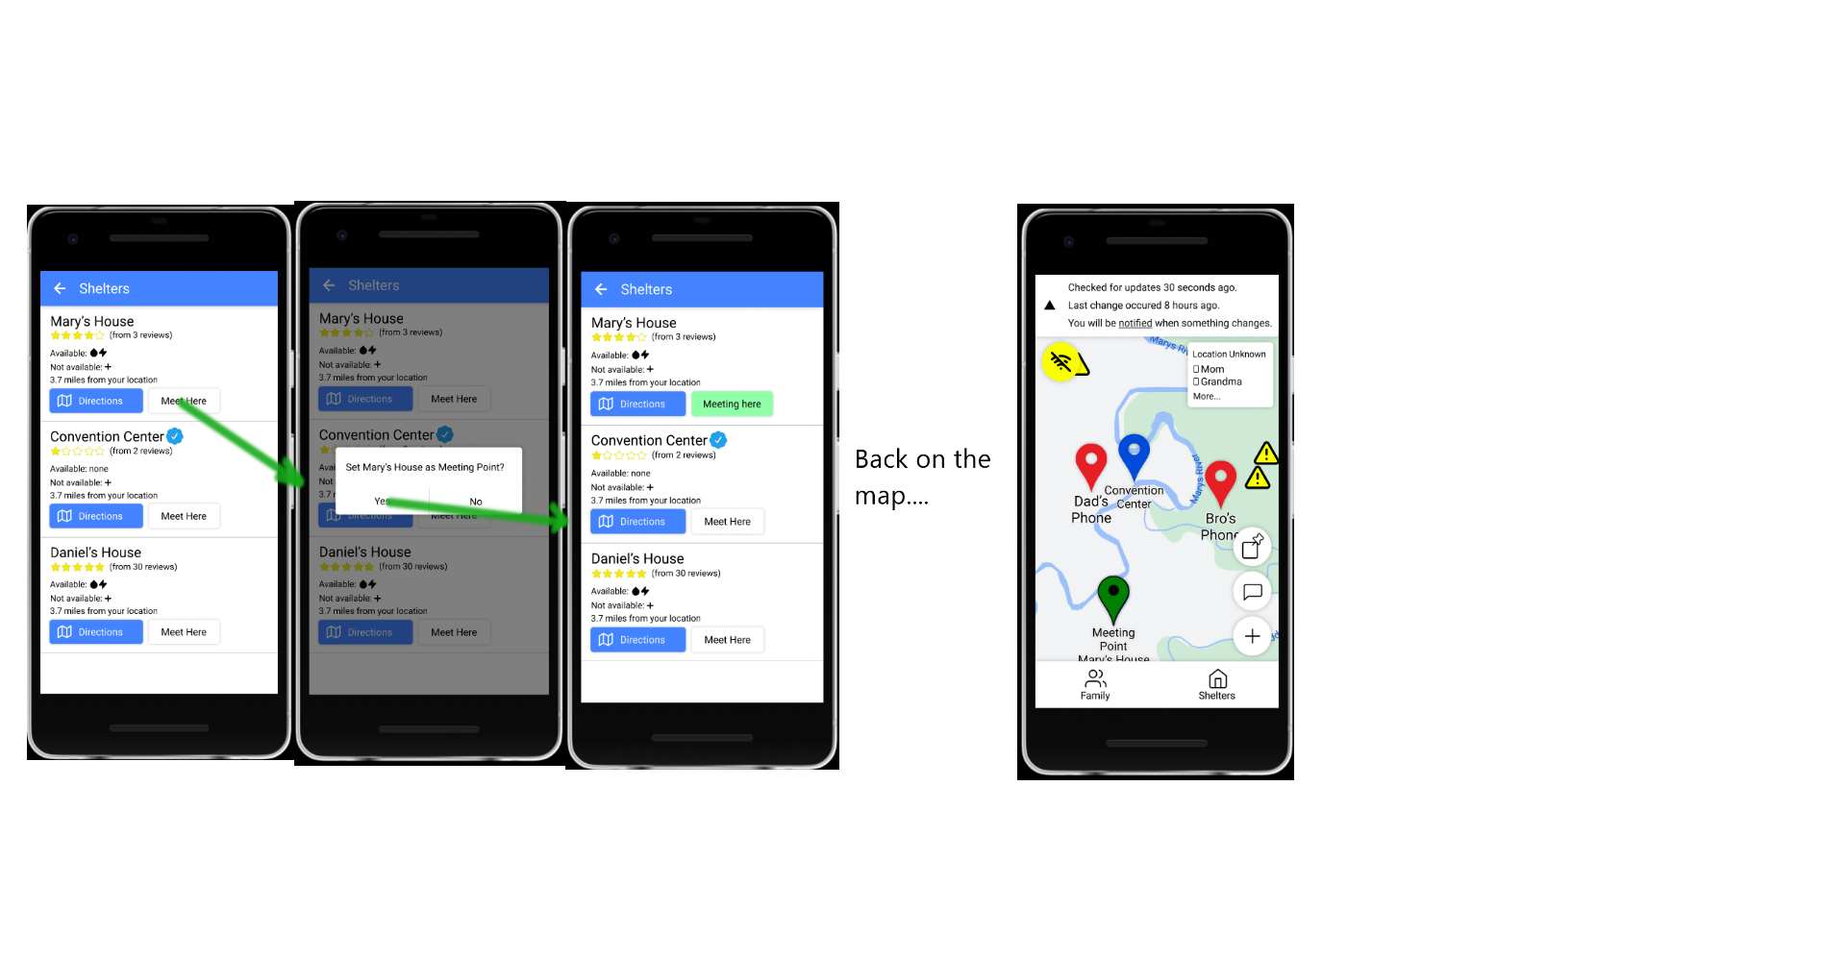
2. If Janet wants more information about Mary’s house, she can tap on it (either in the list or in the popup). This last screen is medium fidelity (see next page). Also note that resources do not match up, but we’re just trying to demonstrate what it would look like.

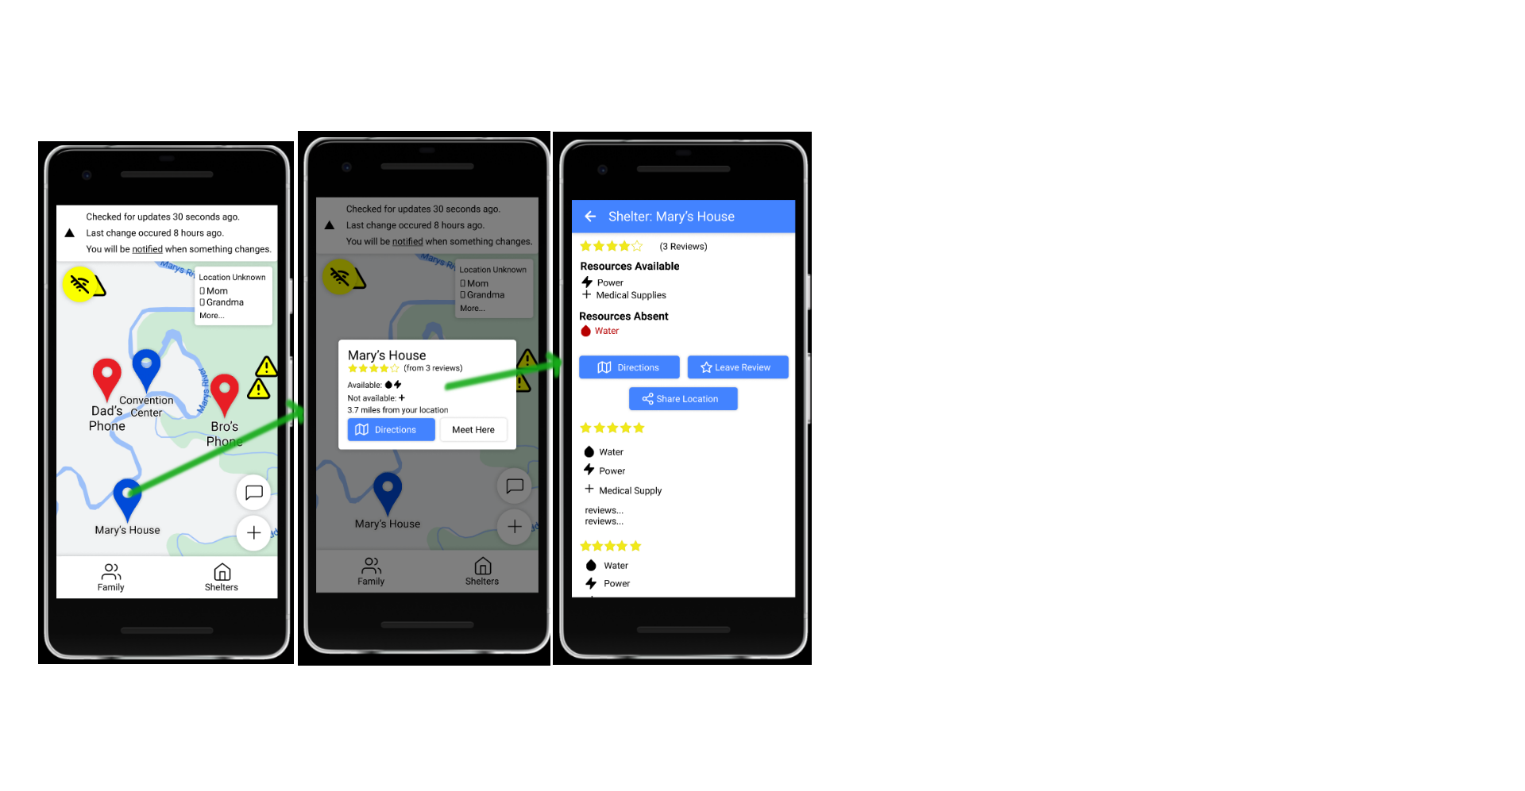

**High fidelity:** Generating direction, tutorials, and other important information that is succinct and easily memorized such that running out of battery doesn’t completely leave the users in the dark.

Specific use case: (continued from before) Janet wants to find directions to “Mary’s house”, which she picked out as the best place to go in the previous use case.

1. Janet now presses “directions” in the shelter list, where she last ended up. (If she was looking at the popup in the main map, the directions button would also be there).
2. This tasks her to the “Directions” screen. Janet doesn’t have anything to write with, and the yellow battery icon makes her worried about wasting her battery. She thus presses “memorize directions”.
3. This brings her to a screen with a condensed list of directions. Janet prefers to visualize, so she chooses to look at the map. She uses the compass to orient herself, and tries to absorb the directions.
4. She realizes that she should tell her family where she’s going (cue “contacting people in the area”). Before leaving, she taps the “pin” icon, which makes this screen accessible from the map screen. She then presses back to return to the map.

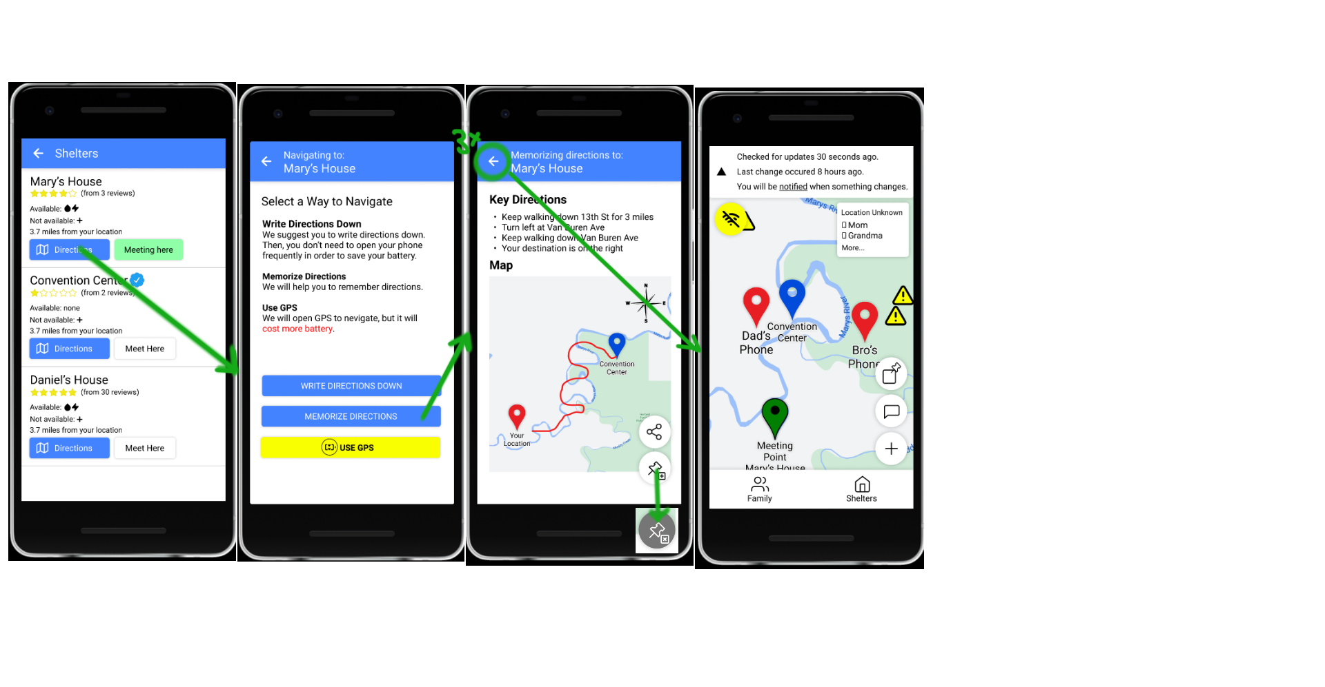

**Medium fidelity:** Finding and contacting people in the surrounding area, especially if “long-range” communication through a cell tower doesn’t work.

Specific use case: Janet wants to send a message to her family that she’s going to Mary’s house.

1. Janet presses the chat button on the map. (She could also press the chat button from inside the family member list if she wants to, but she’s not on the family member list).
2. This takes her to the family circle message. She notices the “no internet; using P2P” banner, but she doesn’t want to read about it right now. She uses the arrow to condense the banner.
3. She taps on her chat bar, and types out “I’m going to mary’s house” using the phone’s standard pop-up keyboard. She hits “send”, to send the message, and presses back to return to the map.
4. Realizing that she has forgotten parts of the directions, she taps the “pinned” button, which takes her directly back to the “memorize directions” page.

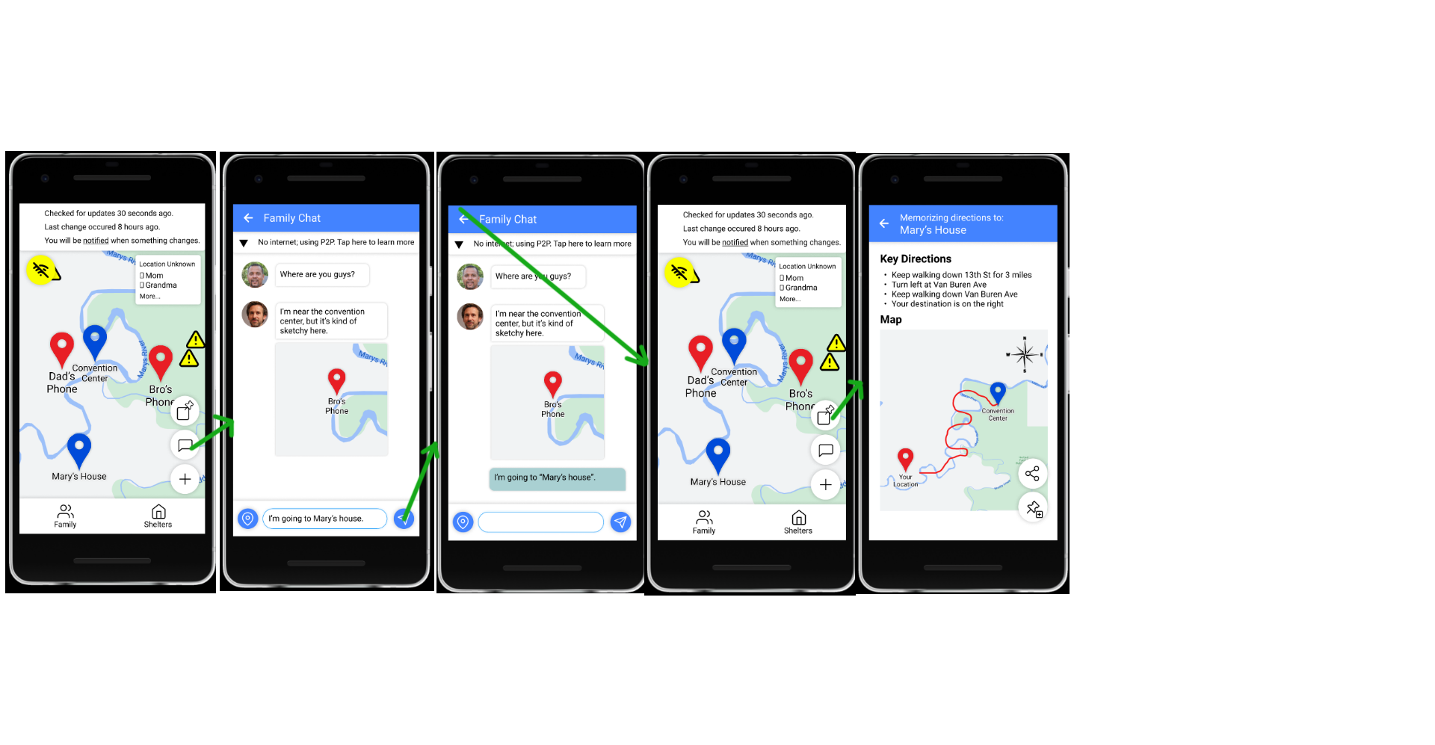

Janet could be worried about P2P, and what that would mean for her. In this case, she presses the “tap here to learn more” on the P2P banner, and is greeted with this screen:

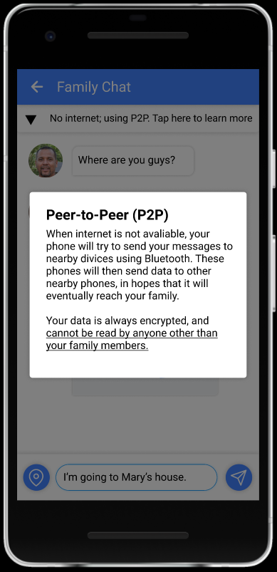

If a user doesn’t have a family circle set (perhaps because they don’t really have anyone they’re close to, which is possible -- our other Persona skeletons indicate this, no broken dataflow, I promise), they are faced with the following screen when tapping “family circle”. They can then enable a “scanning mode” that makes them visible to others.

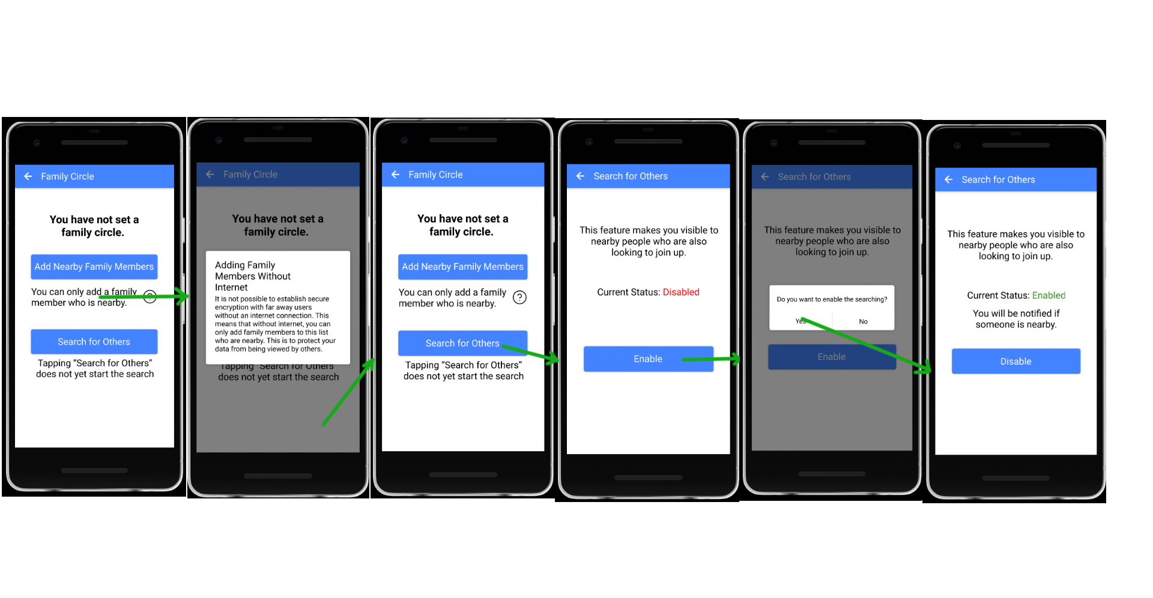

Mainstreamer Use Cases

**High/Medium fidelity:** Seeing the status of a particular neighborhood / area if you’re not there (e.g., family member in Florida, while the user is in Oregon). Users may want to check if their loved one is safe, but cell service likely doesn’t work.

Specific use case: James wants to check and see how his family members in the affected area are doing. Some of their phones are unreachable, so he resorts to simply looking around the area of where their houses are.

1. He sees alert signs of the map, and taps them to learn more. This gives James information about the danger.[1]

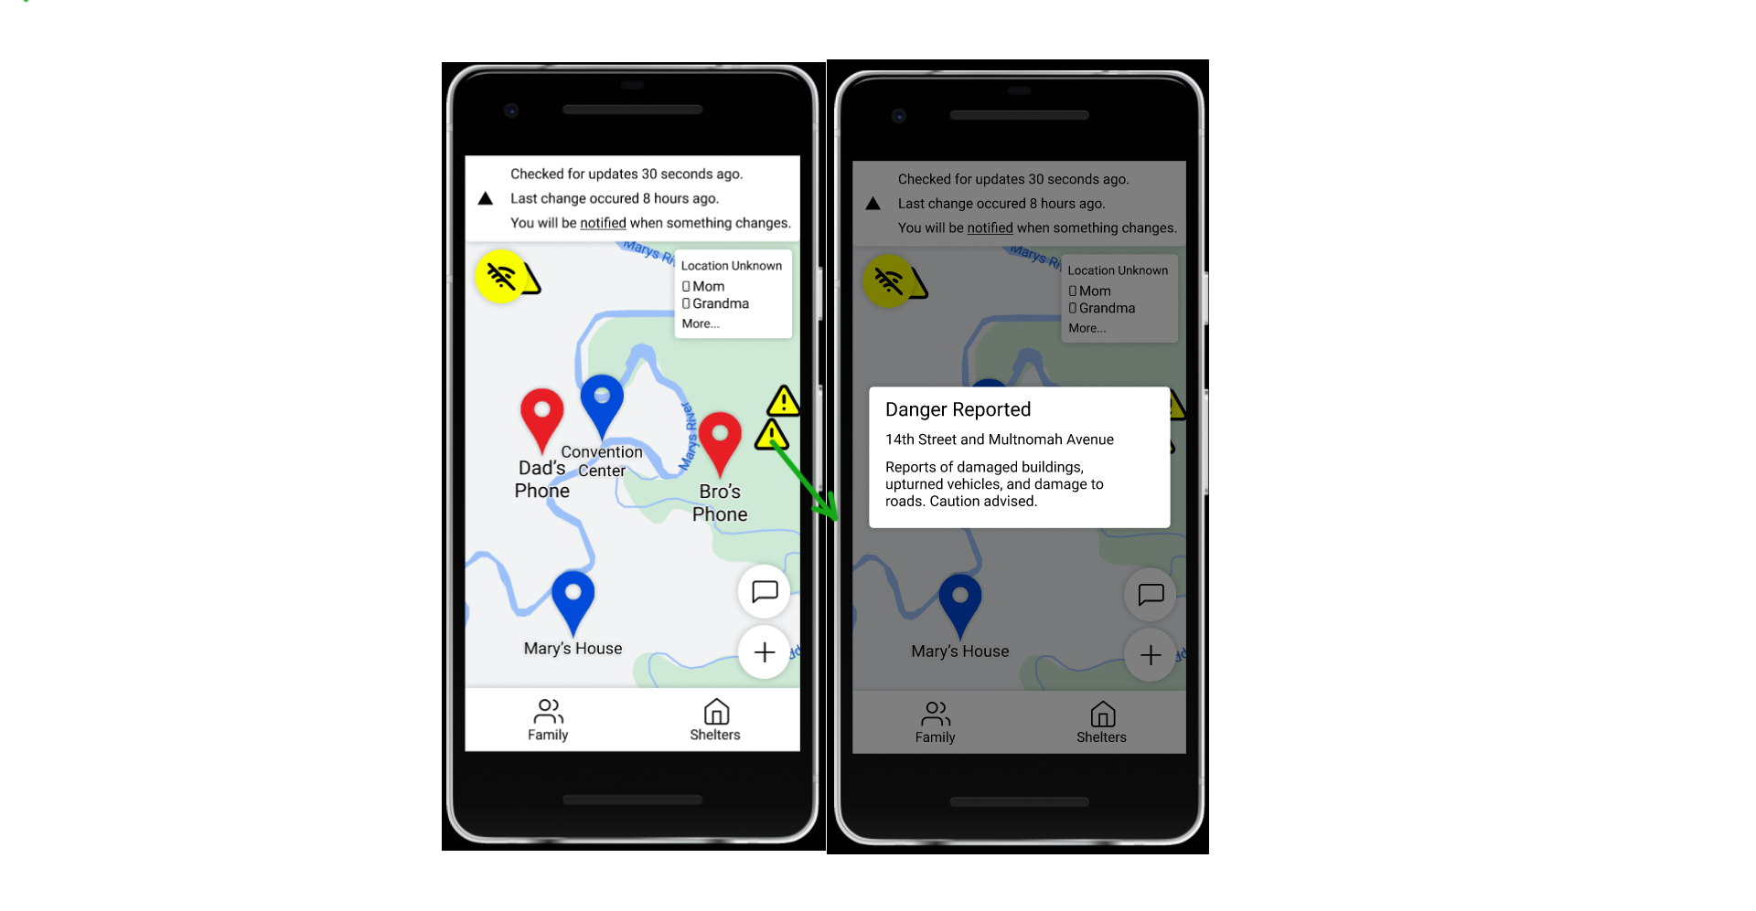

If information about James’ family is available online (a person who was near his parents had internet access and had time to upload data), he can follow the same steps as Janet in looking around to check on his family members (see above)

**High fidelity:** See when a person they know has been lastly active. This isn’t necessarily tied to a map, but perhaps a record of “this person came online 10 minutes ago” would be a lot more comforting than radio silence or a blanket statement about a person’s neighborhood.

James wants to check in on his family members. He can use the same process as Janet when looking for them (see above). In addition, James can also tap the “last updated 30 seconds ago” banner, which takes him to a history screen. (Janet can tap this too, but didn’t choose to).

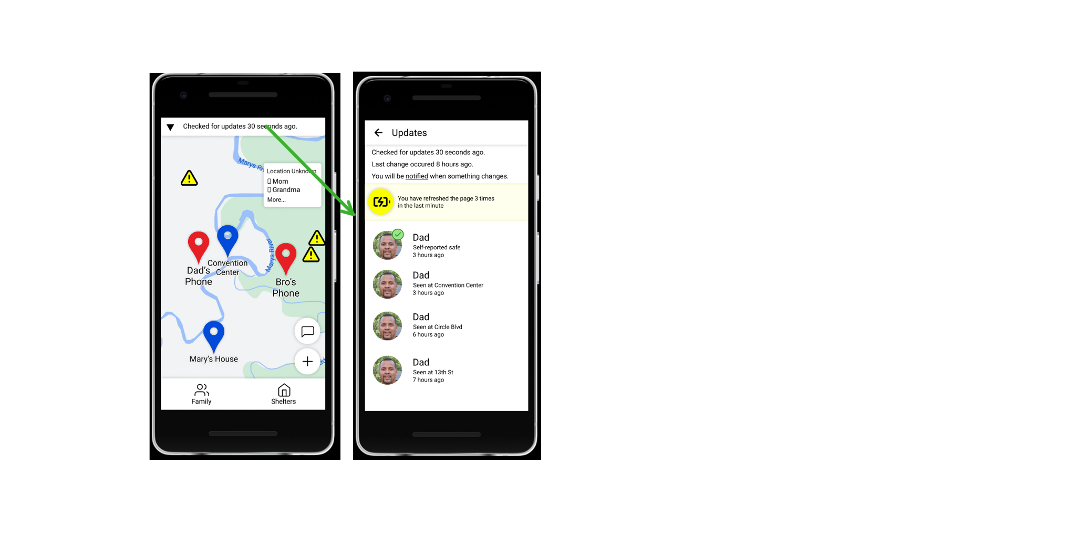

**Medium fidelity:** Locate nearby active shelters to find where to look for their family members whose homes are likely destroyed.

James can follow the same process as Janet in finding a safe place (looking around near family members’ location markers, clicking the nearby shelters). Since he is not as concerned about battery power, though, he’s more interested in using GPS.

1. James hasn’t received the meeting point because Janet doesn’t have internet, and because the meeting point data hasn’t reached any other nearby phone that does. He thus picks a shelter near where he thinks she is. To save prototyping effort, we’ll say that this shelter is also Mary’s house.
2. He presses directions.
3. Unconcerned about the battery, he taps the GPS button. He wants to avoid dangers on the road, which are listed in the application. He previews the route, presses start, and is on his way.

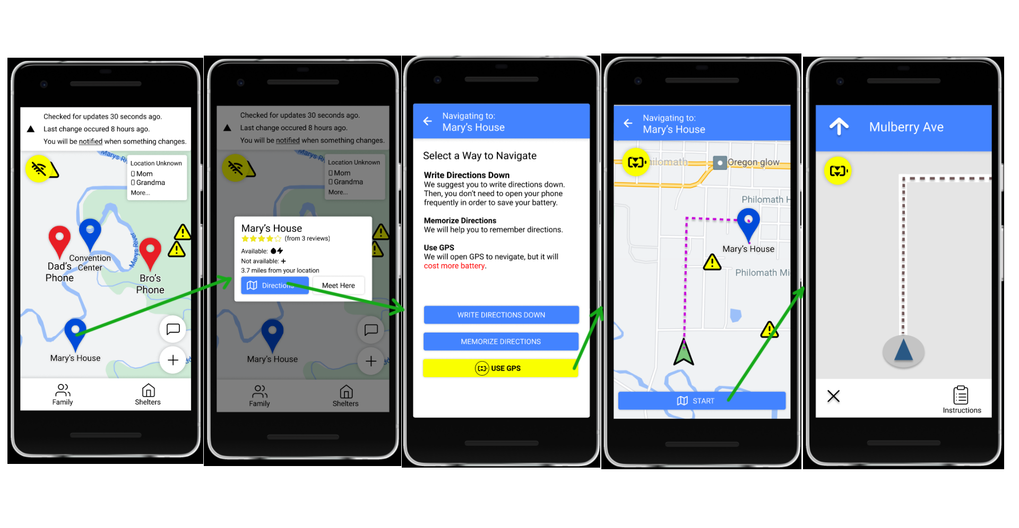

James may also want to write the directions down, given that he may not have internet when he gets there (or if something goes wrong). In this case, he can use detailed direction much like our underserved persona would:

1. James clicks on the shelter he’s interested in
2. He taps directions to get directions there
3. Since he has free access to paper and writing utensils, he taps “write directions down”.
4. He sees the map, but prefers to take down the step-by-step directions, so he taps instructions.
5. He can now write down the directions to Mary’s house.
6. For his convenience, he can tap on the current direction line he’s on to highlight it, so he can keep track of where he is.

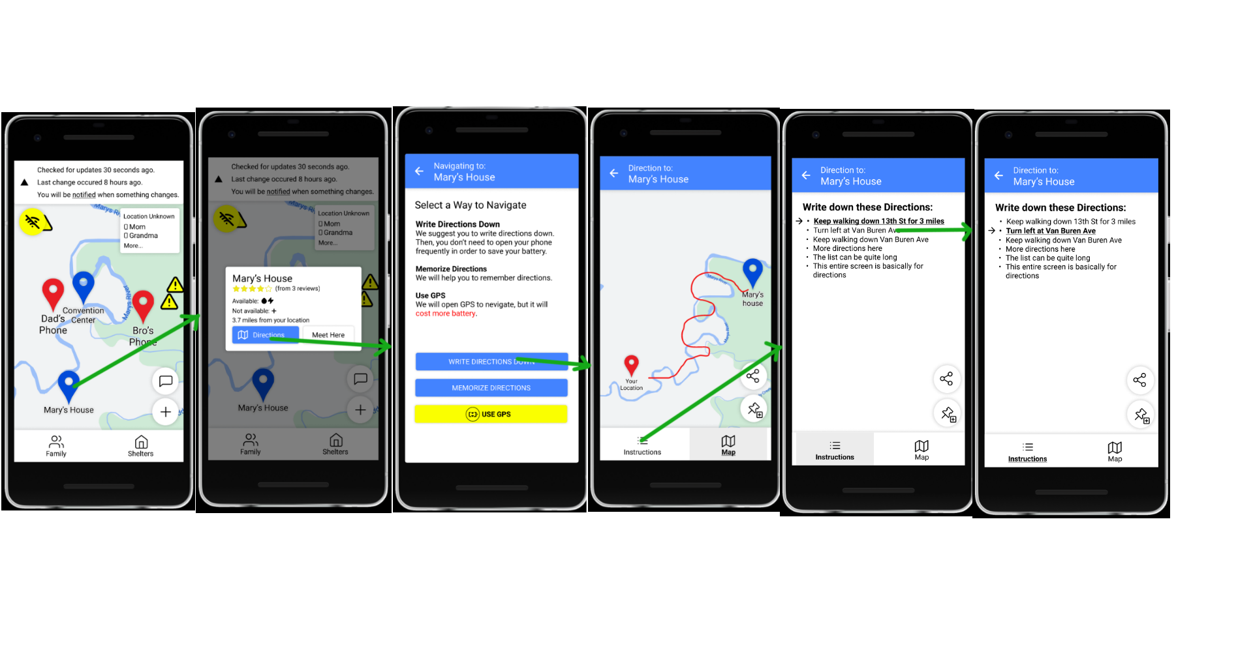

1. Note: dangers can be reported online and by people in the local area. Dangers reported from other sources (online) are visible to everyone with an internet connection; dangers reported by people are visible to those reachable via Peer-to-Peer (nearby communication over bluetooth), and, if any of the reachable people has an internet connection, they are also uploaded for everyone to see.